Jenkins Configuration as code:

Tracking is problem with manual configuration.

It is trackable if CaaS easily.

Pipeline jobs:

To execute jenkins job we use groovy code or jenkins DSL.

Jenkins code is already predefined using DSL. If you want to customize it then we will go for groove code.

Using multi branch pipeline we can create set of pipeline projects according to detected branches in one SCM Repo.

DSL Methods:

2 ways:

Ref library : Specific to one jenkins file. (Local Method)

shared-library (Global method)

CT:

Selenium testing is used perform UI testing using browser.

testcase as code.

Top tools used for Automated testing:

Selenium

Cucumber

Appium

Test studio

Selenium is testing framework where you can do functionality test of your web applications.

Selenium is usually used if you want to test the web application frequently.

junit testing

UI Testing -->Selenium-->Supports Java/python/c#/perl/ruby

OS: win/mac/linux

Functionl testing comes in CI and Unit testing under CI.

Browser: Firefox,chrome,safari,opera,IE

Selenium components:

1. Selenium IDE: In order to speed up test case creation this component was used. Here Selenium IDE is Firefox extension. It basically records the actions done on website and converts it to Java code. eclipse/intellij/visual studio

2. Selenium RC: Due to same origin policy testers had to install selenium core and web server on their local system. This was done to keep domain name same for selenium core and web application to be tested. Selenium RC is as web server which acts as HTTP Proxy. It tricks OS into believing both selenium core and website to be tested are on same domain.

3. Selenium web drivers: used to connect to browser/launch a code in browser. It is cross platform testing framework that could control the browser from the OS level. It controls the browser by directly communicating to it.

4. Selenium grid: Can run multiple test cases simultaneously can connect to multiple nodes to run multiple tasks. It enables to run parallel testing of applications on multiple machines. It can also be used to break down huge test case suit among many computers testing same application.

once this is ready can be integarted with Maven -->testng-->selenium class or method.

Selenium |

client |

libraries |

Javascript|

Java | Jsonwire

PHP |====>protocol over ===>selenium ==>Browser driver (IE/Chrome/FF/Safari)===>Real Browser

C# | HTTP server

Python |

How to run selenium test cases using python?

Maven-->testng-->java classes/methods-->Selenium driver-->browser

Java:

Class: template /blue print of object

Object: physical data/ Instance of class

Variable:

Oops:

Abstraction

Inheritance

Encapsulation

Polymorphism

import org.openqa.selenium.WebDriver;

import org.openqa.selenium.firefox.FirefoxDriver;

public class selenium1 {

public static void main(String[] args) throws InterruptedException {

selenium1 selobj = new selenium1();

selobj.seltestcase1();

selobj.seltestcase2();

}

public void seltestcase1() throws InterruptedException {

System.setProperty("webdriver.gecko.driver", "C:\\Users\\alokv\\Downloads\\geckodriver.exe");

WebDriver driver=new FirefoxDriver();

driver.get("https://www.google.com/");

System.out.print(driver.getTitle());

if(driver.getPageSource().contains("I'm Feeling Lucky")) {

System.out.print("test case1 success");

}

else {

System.out.print("test case1 failure");

}

Thread.sleep(1200);

driver.close();

}

public void seltestcase2() throws InterruptedException {

System.setProperty("webdriver.gecko.driver", "C:\\Users\\alokv\\Downloads\\geckodriver.exe");

WebDriver driver=new FirefoxDriver();

driver.get("https://www.google.com/");

System.out.print(driver.getTitle());

if(driver.getPageSource().contains("I'm Feeling Lucky")) {

System.out.print("test case1 success");

}

else {

System.out.print("test case1 failure");

}

Thread.sleep(1200);

driver.close();

}

}

public void loginBrowser() {

System.setProperty("webdriver.gecko.driver", "C:\\Users\\alokv\\Downloads\\geckodriver.exe");

WebDriver driver = new FirefoxDriver();

driver.manage().window().maximize();

driver.manage().deleteAllCookies();

driver.manage().timeouts().pageLoadTimeout(100,TimeUnit.SECONDS);

driver.manage().timeouts().implicitlyWait(100,TimeUnit.SECONDS);

driver.get("https://www.facebook.com");

driver.findElement(By.name("email")).sendKeys("alokchinnu87@gmail.com");

driver.findElement(By.name("pass")).sendKeys("kanakeri123");

driver.findElement(By.id("loginbutton")).click();

}

Headless mode: Background execution.No browser will be opened.It will save execution time.

FirefoxBinary firefoxBinary = new FirefoxBinary();

firefoxBinary.addCommandLineOptions("--headless");

FirefoxOptions firefoxOptions = new FirefoxOptions();

firefoxOptions.setBinary(firefoxBinary);

Selenium Grid: can connect multiple selenium instances simultaniously.can invoke multiple browsers in different machines.Is a network of hub and nodes. Each node registers to HUB with a cerrtian configuration and HUB is aware of the browsers available on the node. When request comes to HUB for a specific browser,the hub ,if found a match for the requested browser,re directs the call to that particular GRID node and then a session is established bi directionally and execution starts.

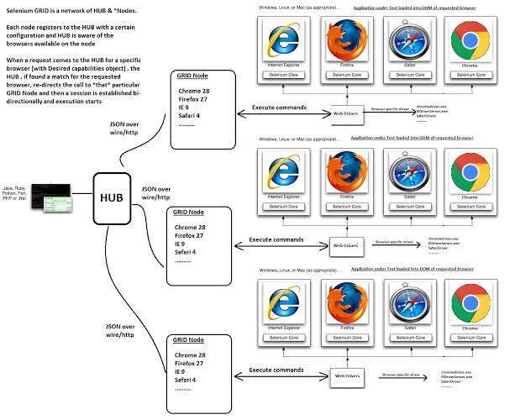

### Starting a Hub

java -jar selenium-server-standalone-2.44.0.jar -role hub

### Starting a Node

java -jar selenium-server-standalone-2.44.0.jar -role node -hub http://localhost:4444/grid/register

Surefire plugin is used to run test cases. It is maven Plugin.

TestNG: Is used to run